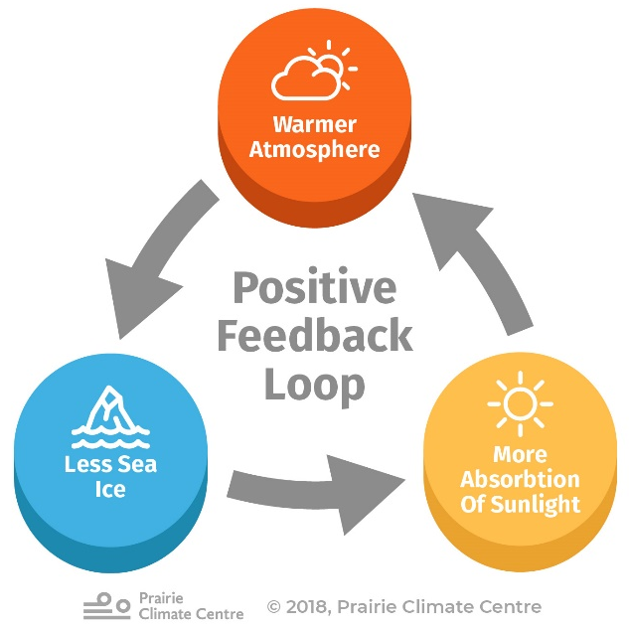
Topic 1 – D4.3: Climate change
- Theme: Continuity and change
- Level: Ecosystems,
Guiding questions:
- What are the drivers of climate change?
- What are the impacts of climate change on ecosystems?
Note – these are overarching questions, taken from the syllabus. They are not directly part of your summer work task, but give a framework to help focus your thinking.

What you will produce:
- Please record your summer work as either
  - A poster of size A3 or A2, including references on the back
  - A presentation of 8-12 slides, not including any title and reference slides
- Referencing should include the full URLs for any websites used. For printed resources the title, author should be included, as well as page references if applicable.

Deadline: Your first SL biology lesson in September. I recommend bringing this to the first biology lesson until you confirm the codes for the SL lessons, which all students attend, and the HL only lessons.

Tasks: Carry out research to complete the tasks below and over the page.
- Summarise the positive feedback cycles that occur in global warming, in interconnected pictorial diagrams or flow charts (see example above), to include:
  - Increases in absorption of solar radiation due to loss of reflective snow and ice
  - Accelerating rates of decomposition of peat and previously undecomposed organic matter (eg, dead organisms and waste) in permafrost
  - Release of methane from melting permafrost
  - Increases in droughts and forest fires
  - Release of carbon dioxide from deep ocean
  - Note – positive feedback = a process where the outcome of an action causes more of that action to occur, intensifying the response.​

- Explain one example of the impact of climate change on an ecosystem, choosing from this list.
  - Why have some boreal forests changed from net consumers of carbon, to net producers? You should consider the impact of drought.
  - How have polar habitats changed? You should consider both ‘landfast’ ice and sea ice.
  - How have changes in ocean currents impacted marine food chains? You should consider nutrients rising to the surface.
  - How and why has the location in which a named species is found changed, moving toward a pole or to higher elevation? You may with to use the montane bird species in New Guinea, or a North American tree species.
  - Why are coral reefs ecosystems potentially collapsing? You should explain coral bleaching and the impact of this on the wider ecosystem.

- HL level students only: explain one further example of the impact of climate change on phenology (which is research into the timing of biological events) or evolution, choosing from this additional list. These biological events include flowering, budburst and bud set in deciduous trees, bird migration and nesting.
  - How has ecosystem temperature change led to a change in timing of a biological event? You might consider Artic mouse-ear chickweed, migrating reindeer or the breeding of the great tit.
  - How and why has climate change affected the number of insect life cycles within a year? You might consider the spruce bark beetle as an example.
  - How has evolution led to adaptation of a named species, as a result of climate change? You might consider how snow cover changes have influenced the adaptation of tawny owls.

- Synoptic link challenge: Using a new colour pen, poster section or slide, make as many links as you can between the content of your summer work and biological concepts you have studied at GCSE or earlier in your scientific education.
(eg) solar radiation is absorbed by chlorophyll during the process of photosynthesis [link to Task 1a]
(eg) carbon dioxide is released in excretion by all living organisms, as a result of respiration [link to Task 1e]

