Key GDC Skills
If you have not yet bought a GDC these will be available to purchase through school in September. Please download the calculator onto a laptop here to practice this summer work.
Skill | Solve Quadratic Equations
Tutorial | https://info.casio.co.uk/hubfs/CAL/Go%20Graphic/Skills%20Videos/Video%201.mp4
Practice | 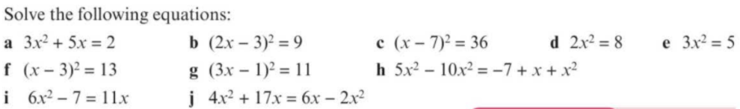
Solutions | 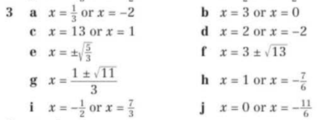

Skill | Solve Simultaneous Equations
Tutorial | https://info.casio.co.uk/hubfs/CAL/Go%20Graphic/Skills%20Videos/Video%202.mp4
Practice | 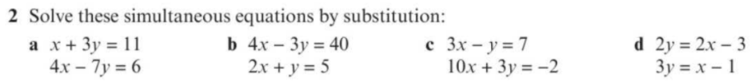  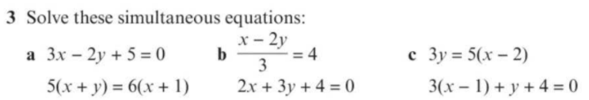
Solutions | 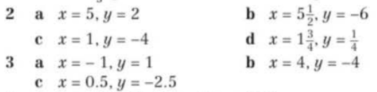

Skill | Draw a Graph and Adjust the Axes and Find Key Points
Tutorial | https://info.casio.co.uk/hubfs/CAL/Go%20Graphic/Skills%20Videos/Video%204.mp4  https://info.casio.co.uk/hubfs/CAL/Go%20Graphic/Skills%20Videos/Video%205.mp4
Practice | 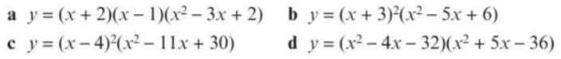
Solutions | 4B Q2a-d  4aQ3ef  2f q1gh  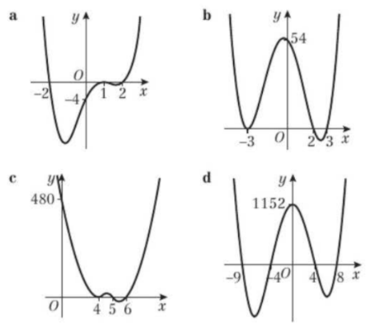  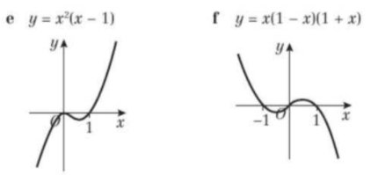  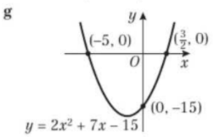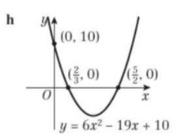

Skill | Calculate Statistics in List Mode
Tutorial | https://info.casio.co.uk/hubfs/CAL/Go%20Graphic/Skills%20Videos/Video%2013.mp4  https://info.casio.co.uk/hubfs/CAL/Go%20Graphic/Skills%20Videos/Video%2014.mp4
Practice | 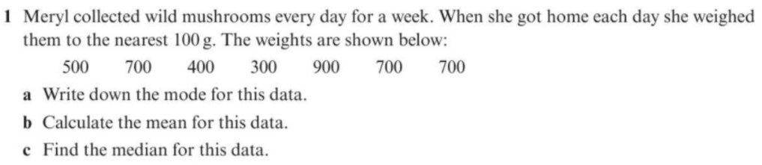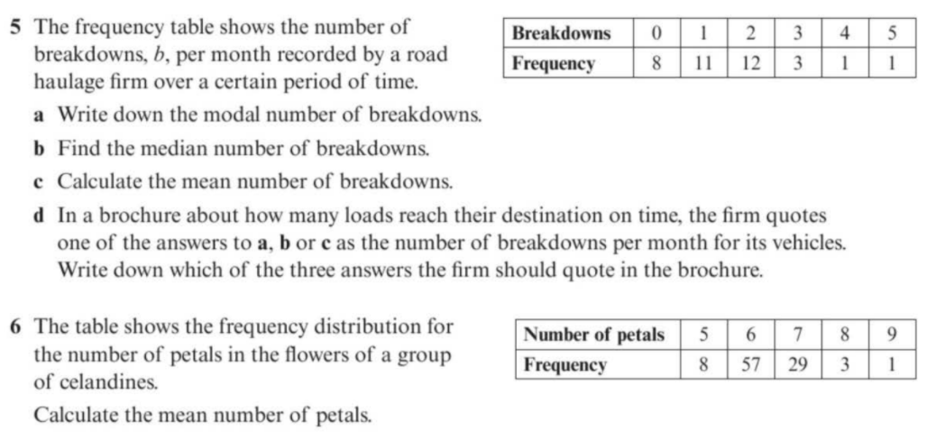
Solutions

