Summer work for IB Theatre

Task: Research into two practitioners
Theatre IB demands that students learn about practitioners and theatre companies-for your summer task you will focus on two: Konstantin Stanislavsky and Antonin Artaud
You will conduct you own research into these two practitioners, finding out about their ideas about theatre. You will then write 200 words on each of them, summing up their theories and ideas as you understand them and explaining in general terms why they are considered important. You do not need to include biographical detail – concentrate on their ideas. If you use the internet, it is good practice to explore at least three sources as information on the internet can be unreliable. You must include a bibliography of your sources.
Task 2: Analysis of live performance.
During sixth form, you will have the opportunity to participate in at least three trips to the theatre. You will develop the skills of performance analysis and strengthen your understanding of how meaning is created in theatre, and in both courses your ability to analyse and reflect upon live performance will be assessed.
Go to the theatre, locally or in London, to watch a play or musical, then answer the following questions. Your answers to each question should be at least 200 words in length and include analysis and examples. Bear in mind as you write that the person reading your work has not seen the show you are writing about.
- Which actor/performer stood out for you? Explain why, focusing on how the actor used movement, voice, space, facial expression etc. to bring the character to life. Give examples.

- Sketch the set (or performance space if there was no set as such) and analyse the contribution it made to the performance. Write about how the set was used within the production.

- Did you personally enjoy the performance? Explain why (or why not) in detail, giving examples to support your writing. You might like to consider whether you felt the play had a message, whether it felt relevant to you, whether the performances and design elements enhanced the piece or not.
Issues with getting to the theatre? See below for access to some National Theatre productions. I recommend Small Island for incredible design elements!
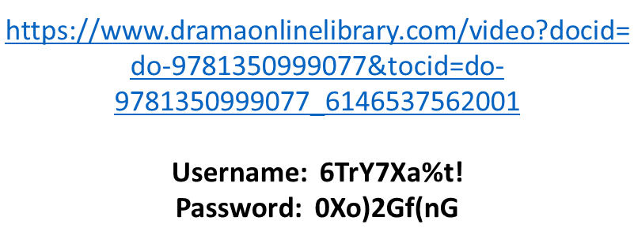

ALL TASKS MUST BE HANDED IN ON YOUR FIRST IB THEATRE LESSON IN SEPTEMBER

